

**SCHOOL INTERNATIONAL**

**COURSE PROJECT 1**

**CMU-CS 246 HIS**

**DEFINED PROCESS DOCUMENT**

Version: 1.1

**E - CALCULATOR APPLICATION – ECA**

**Mentor: Nguyen Dang Quang Huy**

***Team Member*:**

Quy, Tran

Tuan, Le Minh

Duong, Tran Thi Thuy

Thuyen, Tran An

Huy, Nguyen Anh

**Approved by Huy Nguyen Dang Quang**

**Project Plan Review Panel Representative:**

Name Signature Date

**Capstone Project 1- Mentor:**

Name Signature Date

Da Nang, 01/2024

**PROJECT INFORMATION**

| **Project Acronym** | ECA |
| --- | --- |
| **Project Title** | E – Calculator Application | | | |
| **Start Date** | Jan 25th, 2024 | **End Date** | Feb 22th, 2024 | |
| **Lead Institution** | International School, Duy Tan University | | | |
| **Team Member** | **Name** | **Email** | | **Phone** |
| 28211104518 | Tran Quy | tquy5453@gmail.com | | 0396751590 |
| 28212223967 | Le Minh Tuan | leminhtuank0@gmail.com | | 0762528509 |
| 28204645936 | Tran Thi Thuy Duong | thuyduong0796646477@gmail.com | | 0796646477 |
| 28211351997 | Tran An Thuyen | trananthuyen1902@gmail.com | | 0918308551 |
| 28210205517 | Nguyen Anh Huy | anhhuynguyenqn23@gmail.com | | 0896216239 |

**PROJECT PLAN DOCUMENT**

| **Document Title** | Defined Process Document | | |
| --- | --- | --- | --- |
| **Author(s)** | C1CS.5 Team | | |
| **Date** | Jan 26th, 2022 | **File name:** | TEAM 5 – DEFINED-PROCESS-DOCUMENT.docx |
| **URL** | <https://drive.google.com/drive/folders/1SaXOY7FCqZm8dnQh987TkuZzyKIE6NwB?usp=sharing> | | |
| **Access** | Project and CMU Program | | |

**SIGNATURE**

**Document Approvals:** The following signatures are required for approval of this document.

| **Mentor** | Huy, Nguyen Dang Quang | **Signature:** |  |
| --- | --- | --- | --- |
| **Date:** |  |
| **Leader** | Quy, Tran | **Signature:** |  |
| **Date:** |  |
| **Team member(s)** | Tuan, Le Minh | **Signature:** |  |
| **Date:** |  |
| Duong, Tran Thi Thuy | **Signature:** |  |
| **Date:** |  |
| Thuyen, Tran An | **Signature:** |  |
| **Date:** |
| Huy, Nguyen Anh | **Signature:** |  |
| **Date:** |

**REVISION HISTORY**

| **Version** | **Person(s)** | **Date** | **Description** |
| --- | --- | --- | --- |
| **1.0** | All members | Jan 26th, 2024 | Draft |
| **1.1** | Quy, Tran | Jan 28th, 2024 | Final |

**TABLE OF CONTENTS**

**1. PROJECT DESCRIPTION** 4

**2. PROJECT DEVELOPMENT APPROACH** 4

**2.1. TECHNICAL PROCESS 4**

**2.1.1. REASON FOR SELECTING** **4**

**2.1.2. WATERFALL METHODOLOG 4**

**2.1.3. WATERFALL PROCESS 5**

**3. REFERENCES 6**

**Figuare**

**Figure1: Waterfall Process.............................................................................................5**

# 1. PROJECT DESCRIPTION

| **Project code** | ECA | **Contract type** | Internal Project |
| --- | --- | --- | --- |
| **Customer** | N/A | **End-user** | User |
| **Project type** | Internal | **Leader** | Quy, Tran |
| **Project category** | Electronic Calculator | **Business Domain** | Tools |
| **Application type** | Winform Application |  |  |

# 2. PROJECT DEVELOPMENT APPROACH

## 2.1. TECHNICAL PROCESS

We use waterfall methodology in our project, besides using software tools to manage work, assign tasks to team members such as Trello, Slack, Google Drive, Discord, and Source code management tools like git. And for project requirements, we use the Java for winform development with the text document to save database.

## 2.1.1. REASON FOR SELECTING

Waterfall model is known as one of the easiest to understand project management models today, the Waterfall model is a project management method based on a sequential design process. The Waterfall method allows implementing changes at the early stages of the application quite easily for Junior Developers who have no experience in developing software projects.

## 2.1.2. WATERFALL METHODOLOG

Waterfall methodology is a linear and sequential approach to software development and project management. It follows a structured, step-by-step process where progress is seen as flowing steadily downwards through phases, much like a waterfall.

## 2.1.3. WATERFALL PROCESS

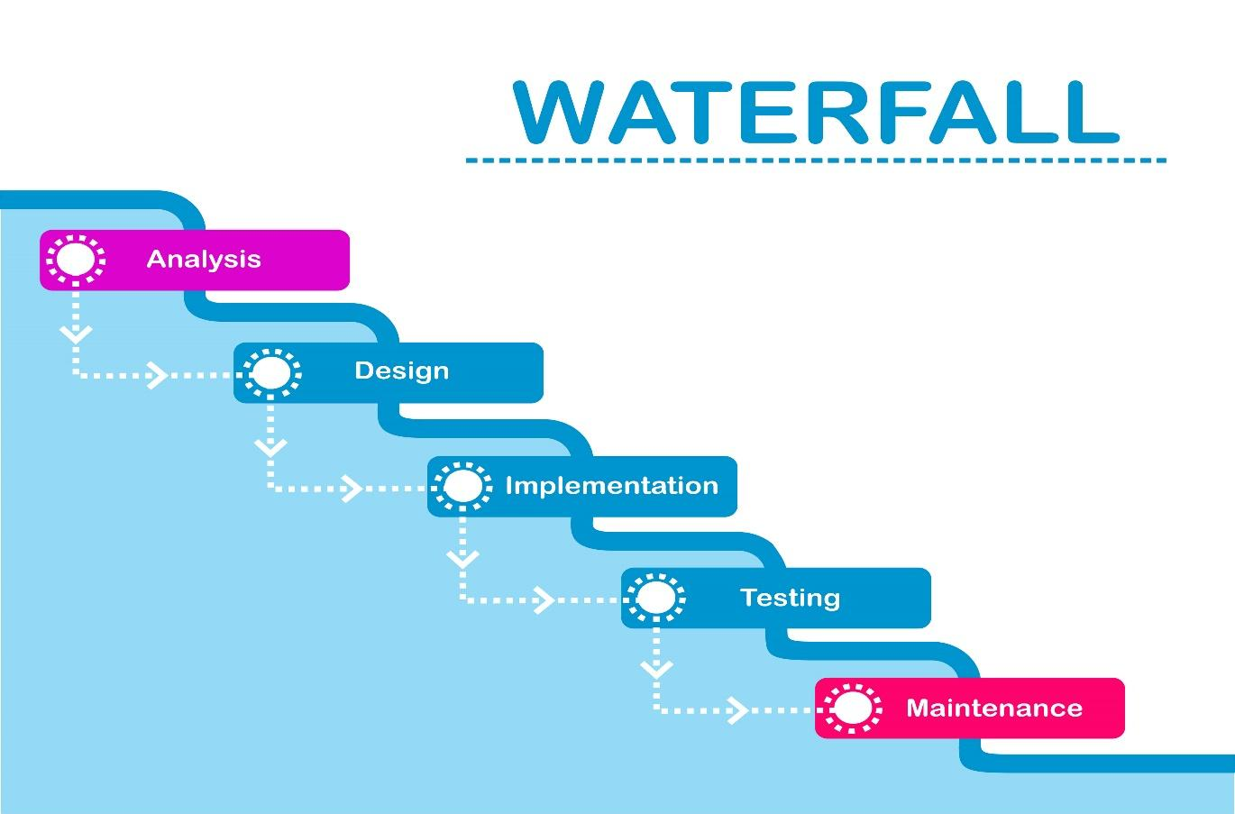

**Figure1:** Waterfall Process

* **Requirements:**
  + Gather and document all the requirements for the project.
* **Design:**
  + Create a detailed system design based on the gathered requirements.
* **Implementation (Coding):**
  + Develop the software based on the designed system.
* **Testing:**
  + Conduct testing to identify and fix defects and issues.
* **Maintenance:**
  + Provide ongoing maintenance and support for the software

# 3. REFERENCES

1. <https://www.atlassian.com/agile/project-management/waterfall-methodology>
2. <https://www.techtarget.com/searchsoftwarequality/definition/waterfall-model>